## “ONLINE MUSICAL WEBSITE - SPOTIFY CLONE ”

A Project report submitted

**In the partial fulfilment the award of degree of**

**BACHELOR OF TECHNOLOGY**

**IN**

**ELECTRONICS AND COMMUNICATION ENGINEERING (2022-2023)**

**BY**

**STUDENT NAME: V. SURYAKALA**

**Reg.No.: 211801400013**

**Under the esteemed Guidance of**

**Mrs. G. Rama Devi, M.Tech,(Ph.d),Asst. Professor**



## **CENTURION UNIVERSITY SCHOOL OF ENGINEERING AND TECHNOLOGY**

**Rollavaka village, Tekkali mandal 535003**

**(2022-2023)**

CENTURION UNIVERSITY OF TECHNOLOGY AND MANAGEMENT

### ANDHRA PRADESH

#### (2019-2023)

DEPARTMENT OF COMPUTER SCIENCE AND ENGINEERING



## BONAFIDE CERTIFICATE

**This is to certify that the project work entitled** “ONLINE MUSICAL WEBSITE SPOTIFY CLONE” **is a fulfilment of project work done by** V.SURYAKALA(Reg.No.:211801400013) **for the award the degree of** BACHELOR OF TECHNOLOGY **in** ELECTRONICS AND COMMUNICATION ENGINEERING, CENTURION UNIVERSITY OF TECHNOLOGY AND MANAGEMENT**, during the academic year** 2022-2023**.**

|  |  |
| --- | --- |
| INTERNALGUIDE | HEAD OF THE DEPARTMENT |
| Mrs .G. Rama Devi | Mr. K.Jogi naidu |
| **Asst. Professor** | **Asst. Professor** |
| **Dept. of CSE** | **Dept. of ECE** |

**EXTERNAL EXAMINER**

# 

# ACKNOWLEDGEMENT

It is with at most pleasure and excitement we submit our project partial fulfillment of the requirement for the award of Bachelor of Technology.

The project is a result to the cumulate efforts, support, guidance, encouragement and inspiration from many of those for whom we have to give our truthful honor and express gratitude through bringing out this project at the outset as per our knowledge.

I convey my special thanks to our project **Guide Mrs. G. Rama Devi(Asst. Professor)** who has guided, encouraged and tremendously supported me to enhance my knowledge with present working of this project to bring out enriching the quality of project.

I express my appreciativeness to **Mr. K.JOGI NAIDU Head of the Department,** who facilitated us to providing the friendly environment which helped to enhance my skills in present project.

I would also like to extend my gratitude to **Dr. K. V. G. KRISHNA MURTHY, Dean-School of Engineering And Technology, Centurion University of Technology and Management** who has helped us to attain all the requirements of the project.

I convey my sincere thanks to **Dr. RAMANA RAO, Ph. D Registrar of Centurion University of Technology and Management** who provided us with an opportunity to take on project work in well-equipped laboratories of Computer Science Department in our college.

At the outset, we thank to **Sri. G.S.N.RAJU**, beloved **Vice Chancellor of Centurion University of Technology and Management** who is the back bone by providing for completion of this project, Thank you sir.

# DECLARATION

I hereby declare that the project entitled **“ONLINE MUSICAL WEBSITE -**

**SPOTIFY CLONE ”** submitted to the fulfilment of award the degree of **B.TECH (ECE)** in

**CENTURION UNIVERSITY OF TECHNOLOGY AND MANAGEMENT**, **ANDHRA PRADESH.**

**STUDENT NAME: V. SURYAKALA Reg.No:211801400013**

## “ONLINE MUSICAL WEBSITE - SPOTIFY CLONE”

A Project report submitted

**In the partial fulfillment the award of degree of**

**BACHELOR OF TECHNOLOGY**

**IN**

**ELECTRONICS AND COMMUNICATION ENGINEERING (2022-2023)**

**BY**

**STUDENT NAME: K.SANDHYA**

**Reg.No.:211801400011**

**Under the esteemed Guidance of**

**Mrs. G. Rama Devi, M.Tech,(Ph.d),Asst. Professor**



### CENTURION UNIVERSITY SCHOOL OF ENGINEERING AND TECHNOLOGY

**Rollavaka village, Tekkali mandal 535003**

**(2022-2023)**

CENTURION UNIVERSITY OF TECHNOLOGY AND MANAGEMENT

#### ANDHRA PRADESH

##### (2019-2023)

DEPARTMENT OF COMPUTER SCIENCE AND ENGINEERING



### BONAFIDE CERTIFICATE

**This is to certify that the project work entitled** “ONLINE MUSICAL WEBSITE SPOTIFY CLONE” **is a fulfilment of project work done by** K.SANDHYA(Reg.No.:211801400011) **for the award the degree of** BACHELOR OF TECHNOLOGY **in** ELECTRONICS AND COMMUNICATION ENGINEERING, CENTURION UNIVERSITY OF TECHNOLOGY AND MANAGEMENT**, during the academic year** 2022-2023**.**

|  |  |
| --- | --- |
| INTERNALGUIDE | HEAD OF THE DEPARTMENT |
| Mrs .G. Rama Devi | Mr. K.Jogi naidu |
| **Asst. Professor** | **Asst. Professor** |
| **Dept. of CSE** | **Dept. of ECE** |

**EXTERNAL EXAMINER**

# ACKNOWLEDGEMENT

It is with at most pleasure and excitement we submit our project partial fulfillment of the requirement for the award of Bachelor of Technology.

The project is a result to the cumulate efforts, support, guidance, encouragement and inspiration from many of those for whom we have to give our truthful honor and express gratitude through bringing out this project at the outset as per our knowledge.

I convey my special thanks to our project **Guide Mrs. G. Rama Devi(Asst. Professor)** who has guided, encouraged and tremendously supported me to enhance my knowledge with present working of this project to bring out enriching the quality of project.

I express my appreciativeness to **Mr. K.JOGI NAIDU Head of the Department,** who facilitated us to providing the friendly environment which helped to enhance my skills in present project.

I would also like to extend my gratitude to **Dr. K. V. G. KRISHNA MURTHY, Dean-School of Engineering And Technology, Centurion University of Technology and Management** who has helped us to attain all the requirements of the project.

I convey my sincere thanks to **Dr. RAMANA RAO, Ph. D Registrar of Centurion University of Technology and Management** who provided us with an opportunity to take on project work in well-equipped laboratories of Computer Science Department in our college.

At the outset, we thank to **Sri. G.S.N.RAJU**, beloved **Vice Chancellor of Centurion University of Technology and Management** who is the back bone by providing for completion of this project, Thank you sir.

# DECLARATION

I hereby declare that the project entitled **“ONLINE MUSICAL WEBSITE -**

**SPOTIFY CLONE ”** submitted to the fulfillment of award the degree of **B.TECH (ECE)** in

**CENTURION UNIVERSITY OF TECHNOLOGY AND MANAGEMENT**, **ANDHRA PRADESH.**

**STUDENT NAME : K.SANDHYA Reg.No:211801400011**

## “ONLINE MUSICAL WEBSITE - SPOTIFY CLONE ”

A Project report submitted

**In the partial fulfilment the award of degree of**

**BACHELOR OF TECHNOLOGY**

**IN**

**ELECTRONICS AND COMMUNICATION ENGINEERING (2022-2023)**

**BY**

**STUDENT NAME: P.MOUNIKA**

**Reg.No.:211801130017**

**Under the esteemed Guidance of**

**Mrs. G. Rama Devi, M.Tech,(Ph.d),Asst. Professor**



### CENTURION UNIVERSITY SCHOOL OF ENGINEERING AND TECHNOLOGY

**Rollavaka village, Tekkali mandal 535003**

**(2022-2023)**

CENTURION UNIVERSITY OF TECHNOLOGY AND MANAGEMENT

#### ANDHRA PRADESH

##### (2019-2023)

DEPARTMENT OF COMPUTER SCIENCE AND ENGINEERING



BONAFIDE CERTIFICATE

**This is to certify that the project work entitled** “ONLINE MUSICAL WEBSITE SPOTIFY CLONE” **is a fulfilment of project work done by** P.MOUNIKA(Reg.No.:211801130017) **for the award the degree of** BACHELOR OF TECHNOLOGY **in** ELECTRONICS AND COMMUNICATION ENGINEERING, CENTURION UNIVERSITY OF TECHNOLOGY AND MANAGEMENT**, during the academic year** 2022-2023**.**

|  |  |
| --- | --- |
| INTERNALGUIDE | HEAD OF THE DEPARTMENT |
| Mrs .G. Rama Devi | Mr. K.Jogi naidu |
| **Asst. Professor** | **Asst. Professor** |
| **Dept. of CSE** | **Dept. of ECE** |

**EXTERNAL EXAMINER**

# ACKNOWLEDGEMENT

It is with at most pleasure and excitement we submit our project partial fulfillment of the requirement for the award of Bachelor of Technology.

The project is a result to the cumulate efforts, support, guidance, encouragement and inspiration from many of those for whom we have to give our truthful honor and express gratitude through bringing out this project at the outset as per our knowledge.

I convey my special thanks to our project **Guide Mrs. G. Rama Devi(Asst. Professor)** who has guided, encouraged and tremendously supported me to enhance my knowledge with present working of this project to bring out enriching the quality of project.

I express my appreciativeness to **Mr. K.JOGI NAIDU Head of the Department,** who facilitated us to providing the friendly environment which helped to enhance my skills in present project.

I would also like to extend my gratitude to **Dr. K. V. G. KRISHNA MURTHY, Dean-School of Engineering And Technology, Centurion University of Technology and Management** who has helped us to attain all the requirements of the project.

I convey my sincere thanks to **Dr. RAMANA RAO, Ph. D Registrar of Centurion University of Technology and Management** who provided us with an opportunity to take on project work in well-equipped laboratories of Computer Science Department in our college.

At the outset, we thank to **Sri. G.S.N.RAJU**, beloved **Vice Chancellor of Centurion University of Technology and Management** who is the back bone by providing for completion of this project, Thank you sir.

# DECLARATION

I hereby declare that the project entitled **“ONLINE MUSICAL WEBSITE -**

**SPOTIFY CLONE ”** submitted to the fulfillment of award the degree of **B.TECH (ECE)** in

**CENTURION UNIVERSITY OF TECHNOLOGY AND MANAGEMENT**, **ANDHRA PRADESH.**

**STUDENT NAME : P.MOUNIKA Reg.No:211801130017**

## **TABLE OF CONTENTS**

**1.INTRODUCTION**

1.1 PURPOSE

1.2 SCOPE

1.3 DEFINITIONS ACRONYMS AND ABBREVATIONS

1.4 REFERENCES

1.5 OVERVIEW

**2. OVERALL DESCRIPTION**

2.1 PRODUCT PERSPECTIVE

2.2 PRODUCT FUNCTIONS

2.1.1 LOGIN/SIGN UP PAGE

2.3 BENEFITS

2.3.1 ACCESS TO A VAST LIBRARY OF MUSIC

2.3.2 PERSONALISED MUSIC EXPERIENCE

2.3.3 CONVENIENT AND EASY-TO-USE

2.3.4 SOCIAL AND INTERACTIVE FEATURES

2.3.5 REVENUE GENERATION FOR THE WEBSITE OWNER

2.4 PRODUCT FEATURES

2.4.1 USER REGISTRATION AND LOGIN

2.4.2 MUSIC BROWSING AND SEARCH

2.4.3 PLAYLISTS

2.4.4 MUSIC PLAYBACK

2.5 USER CHARACTERISTICS

2.6 CONSTRAINTS

**3.SPECIFIC REQUIREMENTS**

3.1 EXTERNAL INTERFACE

3.1.1 PHP APPLICATION

3.1.2 MYSQL DATABASE

3.2 FUNCTIONAL REQUIREMENTS

3.2.1 USE CASE SCENARIO

3.2.1.1 USE CASE SCENARIO 1 – USER LOGIN

3.2.1.2 USE CASE SCENARIO 2- NEW REGISTRATION

3.3 DESIGN CONSTRAINTS

3.4 SOFTWARE SYSTEM ATTRIBUTES

3.4.1 RELIABILITY

3.4.2 AVAILABILITY

3.4.3 SECURITY

**1.INTRODUCTION:**

The Spotify clone website is a web-based application designed to provide users with a music streaming service similar to Spotify. The website offers users access to a vast library of music from various artists, genres, and albums, as well as the ability to create playlists, follow other users, and share music. The website is intended to meet the needs of music lovers of all ages and backgrounds, providing an accessible, easy-to-use, and secure platform for discovering new music and enjoying old favorites. With features such as music browsing and search, playlists, following and sharing, and music playback, the Spotify clone website aims to provide an immersive music experience that users can enjoy anytime, anywhere.

* 1. **PURPOSE:**

The purpose of this document is to define the requirements for a Spotify clone website. The website is intended to provide an online music streaming service, similar to Spotify, where users can listen to music, create playlists, follow other users, and share music.

**1.2 SCOPE:**

The scope of this document is to provide a detailed description of the features and functionalities that the Spotify clone website should have. The website should be designed to meet the needs of music lovers of all ages and backgrounds. The website should be accessible, easy to use, and secure.

* 1. **DEFINITIONS, ACRONYMS AND ABBREVIATIONS:**

**1.3.1 USER LOGIN**

A user login is another essential feature of a website that enables users to access their own data and information. With a user login, user can view their interests , songs , podcasts and other information in real-time.

**1.3.2 DASHBOARD**

A dashboard is the main user interface of a music player, providing an overview of subscriber data and system performance in real-time. The dashboard is typically designed to be easy to navigate, with interactive visuals that display data in a clear and concise manner.

#### 1.3.3 REGISTRATION

Registration is a process in this website that enables user providers to create profiles and collect key information about each user.The registration process typically involves collecting user information and other relevant data.

**1.4 REFERENCES:**

<https://youtu.be/xVZqEmRQjLM>

<https://mrunal0502/Spotify-clone>

* 1. **OVERVIEW:**

This is a working document and, as such, is subject to change. In its initial form, it is incomplete by definition, and will require continuing refinement. Requirements may be modified and additional requirements may be added as development progresses and the system description becomes more refined. This information will serve as a framework for the current definition and future evolution of a better online music website player.

**2. OVERALL DESCRIPTION:**

Within the last two decades, music streaming has overtaken other means of listening to music (e.g. purchasing records, CDs, and/or MP3 files from online music services). This being the case, many different streaming services have come to fruition, and different artists have chosen to release their music on different platforms. The goal of this platform is to allow easy access to songs on any platform by allowing users to create, and seamlessly listen to, playlists of songs from any and all of the available streaming services.

**2.1 PRODUCT PERSPECTIVE**

The Spotify clone website will be an online music streaming service, where users can browse, search, and listen to music. The website will allow users to create their own playlists, follow other users, and share music.

**2.2 PRODUCT FUNCTIONS**

A flowchart is a graphical representation of a process, system, or algorithm that uses various shapes, lines, and symbols to illustrate the steps involved. It is a visual tool that helps to understand complex processes by breaking them down into smaller, more manageable components.

The flowchart typically consists of various symbols representing different steps in the process, such as a rectangle to represent an action or process, a diamond to represent a decision point, and arrows to indicate the flow of the process from one step to another.

The symbols are connected by lines to show the sequence and direction of the process.

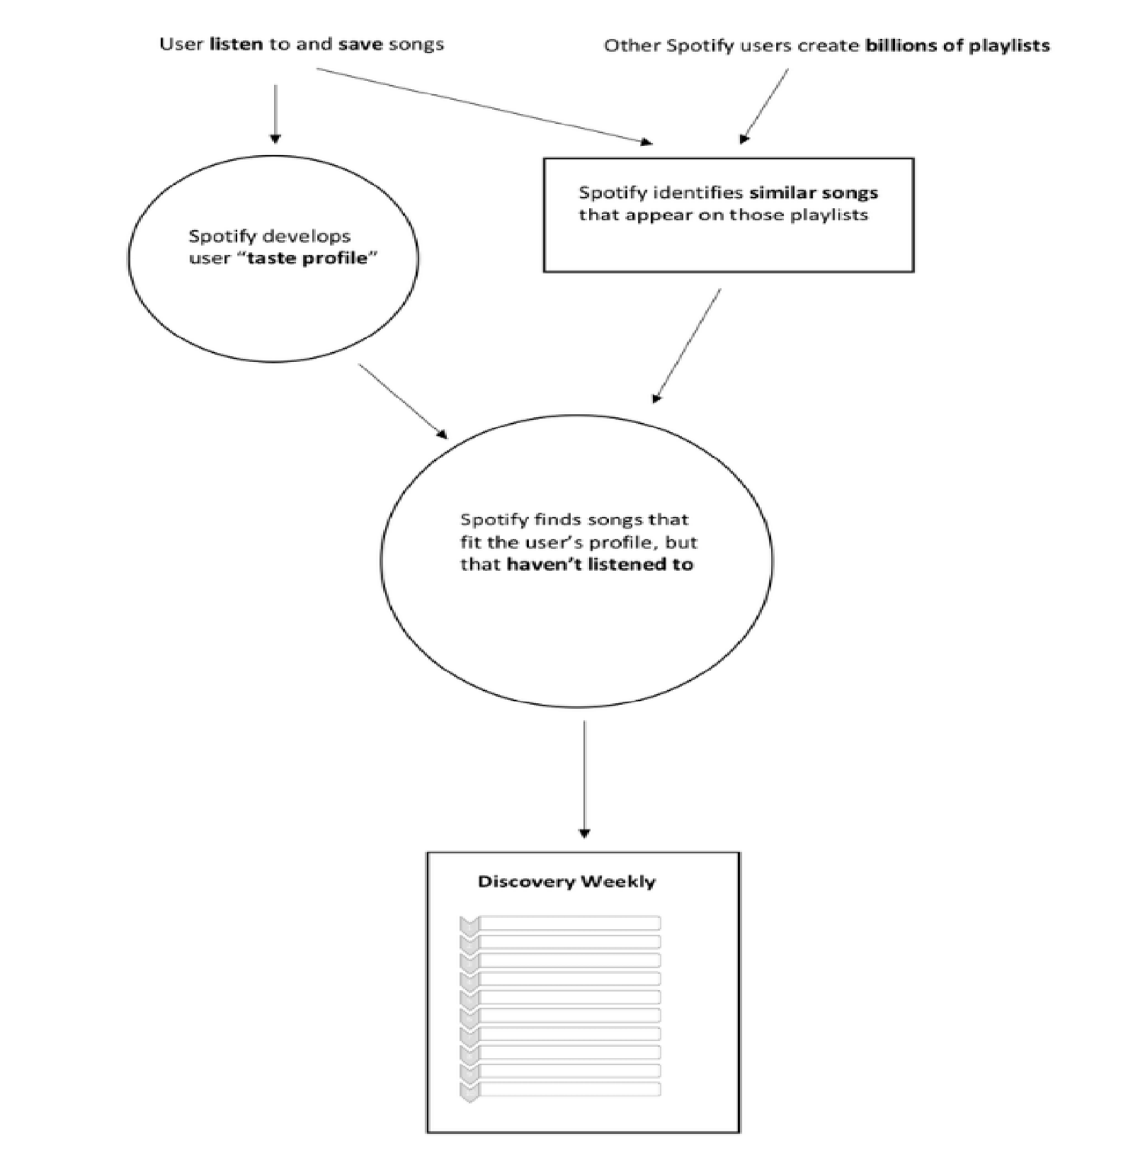

**2.1.1 LOGIN / SIGN UP PAGE**

1. User opens the website and clicks on the "Register" button.

2.User enters their email address, creates a password, and clicks on the "Register" button.

The website stores the user's email and password securely in a database.

User clicks on the "Login" button.

5.User enters their registered email and password and clicks on the "Login" button.

6.The website verifies the user's credentials and grants access to the user's account.

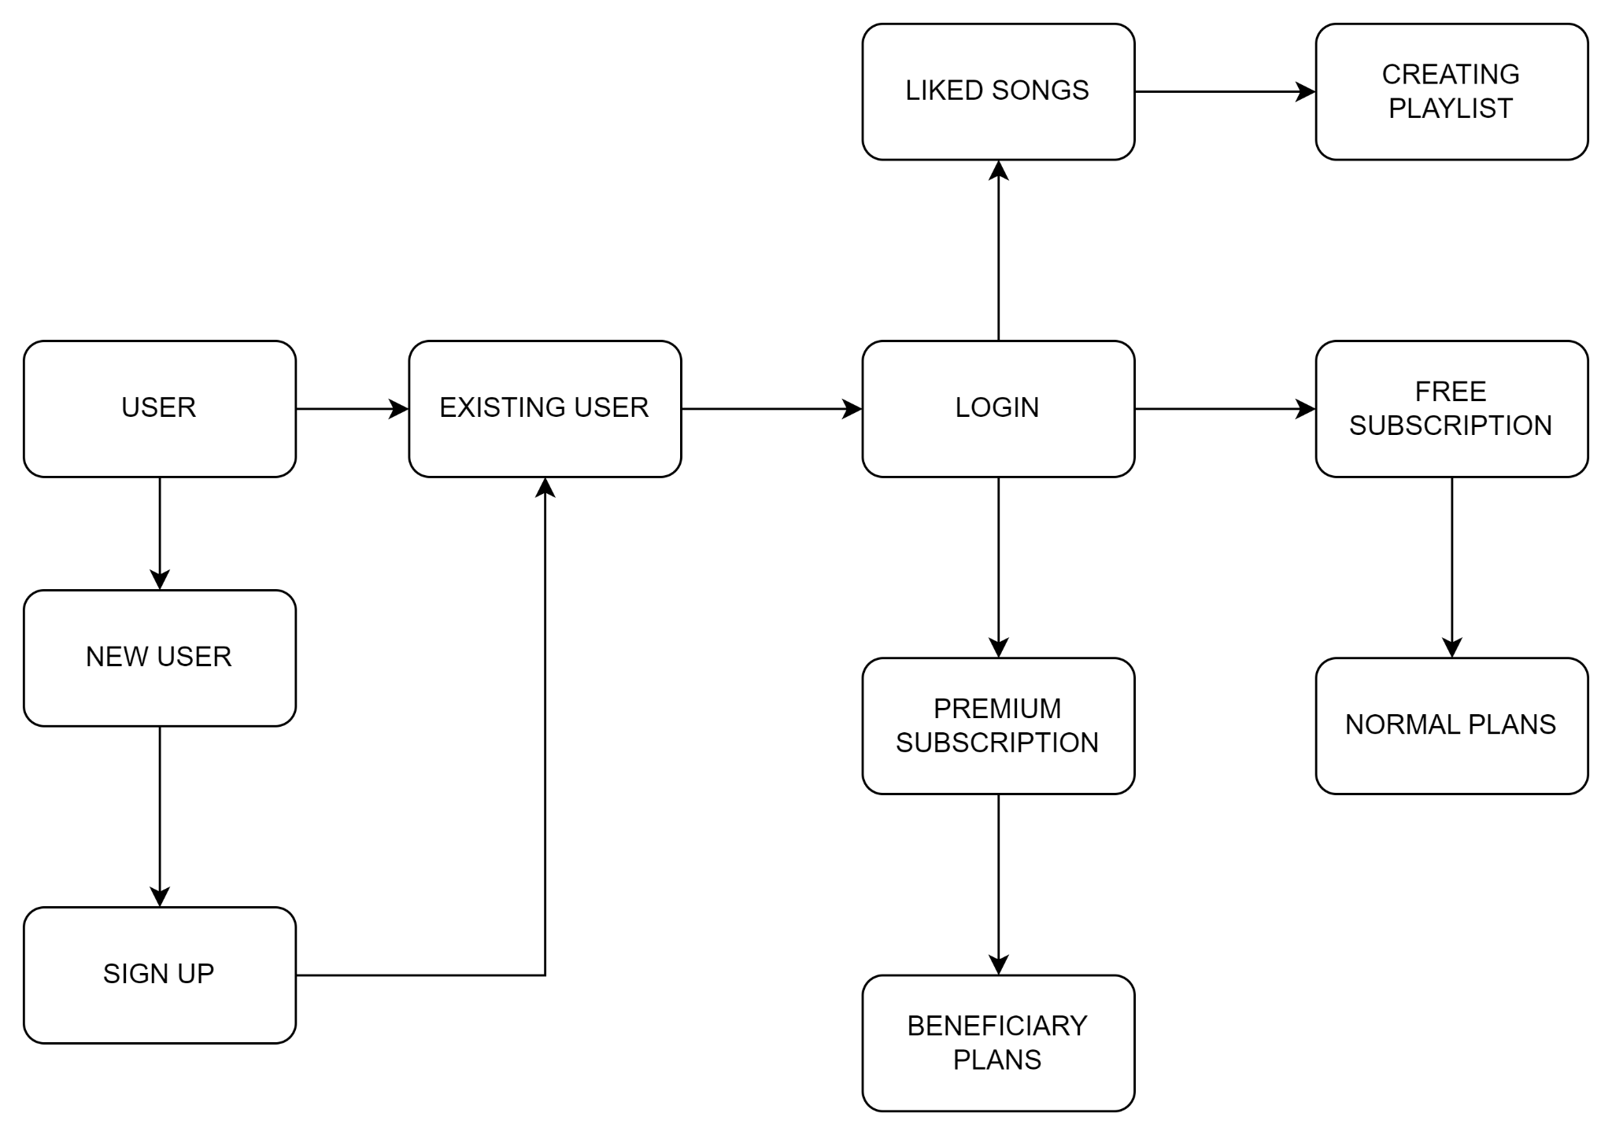

**2.3 BENEFITS**

There are several benefits of a Spotify clone website for both users and the website owner:

**2.3.1 ACCESS TO A VAST LIBRARY OF MUSIC:**

One of the primary benefits of a Spotify clone website is that users can access a vast library of music from various artists, genres, and albums. This provides users with an extensive selection of music to discover, enjoy, and share.

**2.3.2 PERSONALISED MUSIC EXPERIENCE:**

A Spotify clone website can use data analytics and machine learning algorithms to provide users with a personalized music experience. By analyzing user preferences, listening history, and behavior, the website can recommend new music, create personalized playlists, and provide a customized music experience.

**2.3.3 CONVENIENT AND EASY-TO-USE:**

A Spotify clone website is designed to be convenient and easy-to-use, providing users with an intuitive interface for browsing and searching for music, creating and managing playlists, and sharing music with others. The website can be accessed from any device with an internet connection, providing users with a seamless music experience.

**2.3.4 SOCIAL AND INTERACTIVE FEATURES:**

A Spotify clone website can include social and interactive features such as following other users, viewing their playlists, and sharing music with others. This creates a sense of community among users, allowing them to discover new music, share their favorite songs, and connect with other music lovers.

**2.3.5 REVENUE GENERATION FOR THE WEBSITE OWNER:**

A Spotify clone website can generate revenue for the website owner through various means such as advertising, subscription fees, and affiliate marketing. This allows the website owner to monetize the platform and sustain the service while providing users with a high-quality music experience.

**2.4 PRODUCT FEATURES**

The Spotify clone website should have the following features:

* + 1. **USER REGISTRATION AND LOGIN**
* The website should allow users to create an account using their email address and password.
* Users should be able to log in to the website using their registered email and password.

**2.4.2 MUSIC BROWSING AND SEARCH**

* The website should provide users with a list of music genres that they can browse through.
* Users should be able to search for music by artist, album, or song title.
* The website should allow users to filter search results by various criteria, such as artist, album, and genre.
  + 1. **PLAYLISTS**
* The website should allow users to create, edit, and delete playlists.
* Users should be able to add songs to their playlists from search results or their history.
* The website should allow users to share their playlists with other users.
  + 1. **MUSIC PLAYBACK**
* The website should allow users to play music continuously without interruption.
* The website should display album art and song lyrics.
* The website should provide recommendations based on user preferences.
* The website should allow users to like and dislike songs.
* The website should provide a history of recently played songs.

**2.5 USER CHARACTERISTICS**

The target audience for the Spotify clone website is music lovers of all ages and backgrounds. Users should have basic computer literacy and an interest in discovering new music.

**2.6 COSTRAINTS**

The constraint of primary concern is the User’s internet connection.

**3. SPECIFIC REQUIREMENTS:**

**3.1 EXTERNAL INTERFACE**

* + 1. **PHP APPLICATION**

The actual program that will perform the operations is written in PHP. All data will be stored in a database.

**3.1.2 MYSQL DATABASE**

It’s an open source SQL database to store all data which communicates with the application on the server.

* 1. **FUNCTIONAL REQUIREMENTS**
     1. **USE CASE SCENARIO**

**3.2.1.1 USE CASE SCENARIO 1 – USER LOGIN**

**User Login**

|  |  |
| --- | --- |
| **Purpose** | User logs in to system using existing  profile. |
| **User** | A user with an existing profile. |
| **Input Data** | Profile username and password. |
| **Pre-conditions** | User is not logged in to a profile, input profile exists in data base, user password matches profile. |
| **Post-conditions** | User's computer has been supplied with appropriate cookie, page data is appropriate for selected profile. |

**3.2.1.2 USE CASE SCENARIO 2- NEW REGISTRATION**

**New Registration**

|  |  |
| --- | --- |
| **Purpose** | For login the new users can do  Registration  Giving some inputs |
| **User** | A user without an existing profile. |
| **Input Data** | Profile username and password, Email. |
| **Pre-conditions** | Already registered email account can’t be registered. |
| **Post-conditions** | User's computer has been supplied with appropriate cookie, page data is appropriate for selected proϐ ile |

**3.3 DESIGN CONSTRAINTS**

1.The communication between the portal software and the database will be in SQL.

2.The portal layout will be produced with HTML/CSS.

3.The product will be written in PHP.

4.The output must be compatible with W3C XHTML 1.0

5.The source code must follow the coding conventions of PHP.

6.System administrators must have access to comprehensive documentation.

**3.4 SOFTWARE SYSTEM ATTRIBUTES**

The software consists of the following elements:

The PHP application

The MySQL database

The database should remain consistent at all times in case of an error.

**3.4.1 RELIABILITY**

We used languages, frameworks, and packages that have been rigorously tested in industry.

**3.4.2 AVAILABILITY**

We designed this platform on and for a computer browser (rather than mobile). Our

platform works on all Chrome based browsers along with Firefox.

**3.4.3 SECURITY**

The network configuration and servers that our infrastructure is set up on is secured in accordance with AWS Security Best Practices.